Software Requirements Specification Template

BRICK FINDER

Software Requirements Specification

April 02, 2019

Team Members

Bhavika Padidala

Priyanka Bonam

Wendy Eloe

Subhodh Bhargav Lakhinana

Durga Prasd Kallem

Sachin Shetty

Submitted in partial fulfilment

Of the requirements of

CSIS 44691-01 Graduate Directed Project 1

**Table of Contents**

**Table of Contents Page Number**

1. Introduction
   1. Purpose
   2. Scope
   3. Definitions, Acronyms, and Abbreviations
   4. References
   5. Overview
2. General Description
   1. Product Perspective
   2. Product Functions
   3. User Characteristics
   4. General Constraints
   5. Assumptions and Dependencies
3. Specific Requirements
   1. External Interface Requirements
      1. User Interfaces
      2. Hardware Interfaces
      3. Software Interfaces
      4. Communications Interface
   2. Functional Requirements
   3. Use Cases
   4. Class/Objects
   5. Non-Functional Requirements

3.5.1. Performance

3.5.2. Reliability

* + 1. Availability
    2. Security
    3. Portability
  1. Inverse Requirements
  2. Design Constraints
  3. Logical Database Requirements
  4. Other Requirements
  5. Prototypes (for complete project)
  6. Use Case Diagrams

1. Design

4.1. ER diagram

4.2. GUI

1. Analysis Models

5.1. Data Flow Diagram

5.2. Sequence Diagram

6. Technical Manual

6.1 Login page

6.2 Registration

6.3 Dashboards

6.4 Announcements

6.5 User profile page

6.6 Database Functionality

7. End User Manual

7.1 Login page

7.2 Registration

7.3 Dashboard

7.4 User profile page

**UNIT 1: INTRODUCTION**

* 1. **Purpose**

The purpose of the project is to help a donor search for his/her brick location in the Hughes Field House.

* 1. **Scope**

The scope of the project is:

* Save the time of the donor.
* Locate the maps that points to the exact zone number.
  1. **Definitions, Acronyms, and Abbreviations**

**Visual Studio code:** Visual Studio Code is a source-code editor developed by Microsoft for Windows, Linux and macOS. It includes support for debugging, embedded Git control, syntax highlighting, intelligent code completion, snippets, and code refactoring.

**Data Folder**: It has the Excel sheet from where we are reading the data.

**Lib Folder:** It has all the libraries that are generated automatically when we push the code in to the Gthub repo.

**Img Folder:** It has all the images that we are using in the project.

* 1. **References**

<https://code.visualstudio.com/docs>

* 1. **Overview**

The Brick Finder system will help the donor search for the location by entering either the name or inscription in the text field. Once the donor clicks on the search button, they will see a couple of rows with the matching results. They can find their name and by clicking on that particular row they will see a map with the respective zone number on it and also a brick with inscription on it. Also, if the donor wants to print the page they can print it by clicking on the print button which will appear on the page.

**Unit 3. SPECIFIC REQUIREMENTS**

* 1. **External Interface Requirements** 
     1. **User Interfaces**

User interfaces used in this project are mentioned below, Search screen, and Map Screen. We also made the web page responsive so that it looks good even on a Mobile.

**Web Site:**

Search Screen:

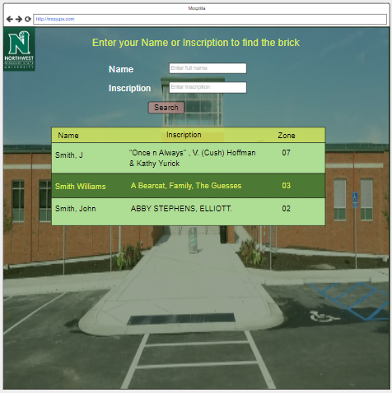

Map Screen:

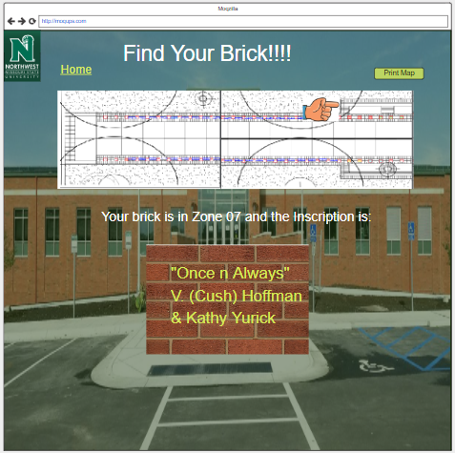

**Mobile site**

Search screen: Map screen:

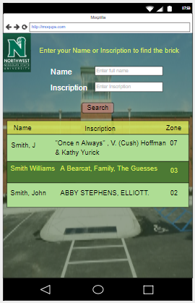 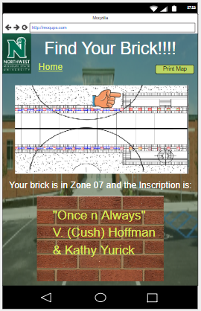

* + 1. **Hardware Interfaces**

Our hardware interfaces are iPhone, iPad, MacBook, Mac Pro, Android devices. Memory should be GB. Operating system using is Windows. Processor is 2.3GHz dual-core Intel Core i5 7th Generation.

* + 1. **Software Interfaces**

jn

**3.1.4Communications Interface**

**Google Docs, sheets and slides:**

Google Docs, sheets and slides lends itself to collaborative projects in which multiple authors work together in real time from geographically diverse locations. All participants can see who made specific document changes and when those alterations were done. Because documents are stored online and can also be stored on users' computers, there is no risk of total data loss as a result of a localized catastrophe. However, the Internet-based nature of Google Docs, sheets and slides has given rise to concerns among some authors that their work may not be private or secure.

We use this for creating project documents, sheets and slides for presentation. It is reliable for team-work.

**Share Point:**

SharePoint is a web-based collaborative platform that integrates with Microsoft Office. Launched in 2001, SharePoint is primarily sold as a document management and storage system, but the product is highly configurable, and usage varies substantially between organizations.

We use share point to work with team on same platform as Microsoft word.

**Outlook:**

It is Microsoft e-mail service. We use outlook to send and receive mails. Used to contact team members.